**Sanzida Parvin**

1. Tableau map visualizations

Locate the Sample - Superstore Subset dataset, which comes built into Tableau. Using this dataset, create two map visualizations:

1. Are there any U.S. states in the dataset that have lost money? Show the profitability of each state using a color scale. For example, the most profitable states should be a darker shade of green than less profitable states. Similarly, use a red color scale (darker to lighter) to show non-profitable states.

Please see the tableau file named **profit_map.twb** in the folder

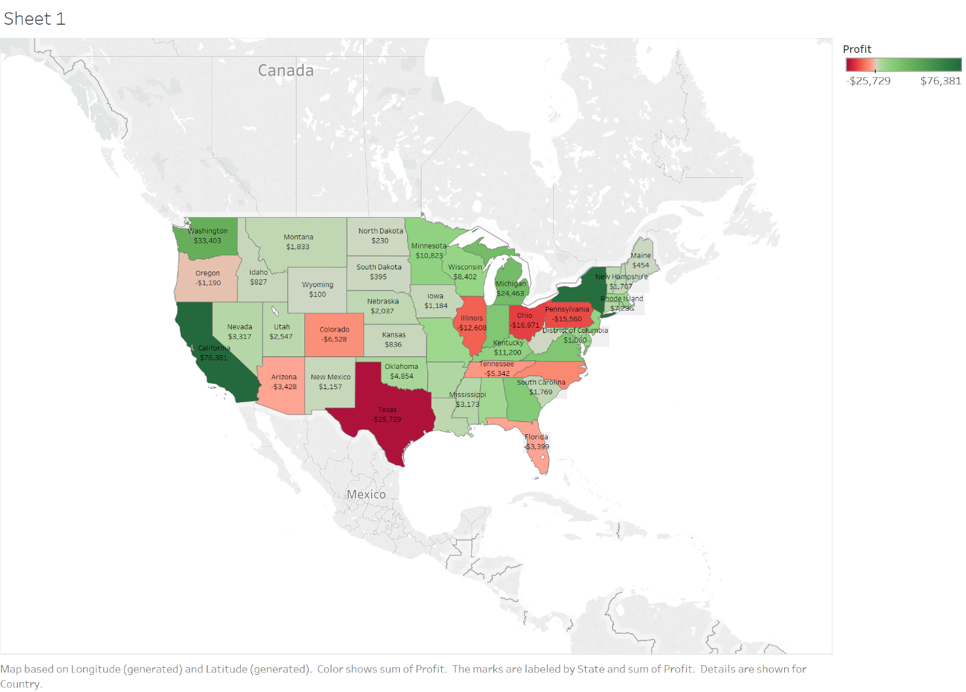

1. Which state has the highest total sales in the dataset? Using a color scale, show the total sales for each U.S. state. Label each state with the state name.

Please see the tableau file named **sales_map.twb** in the folder

